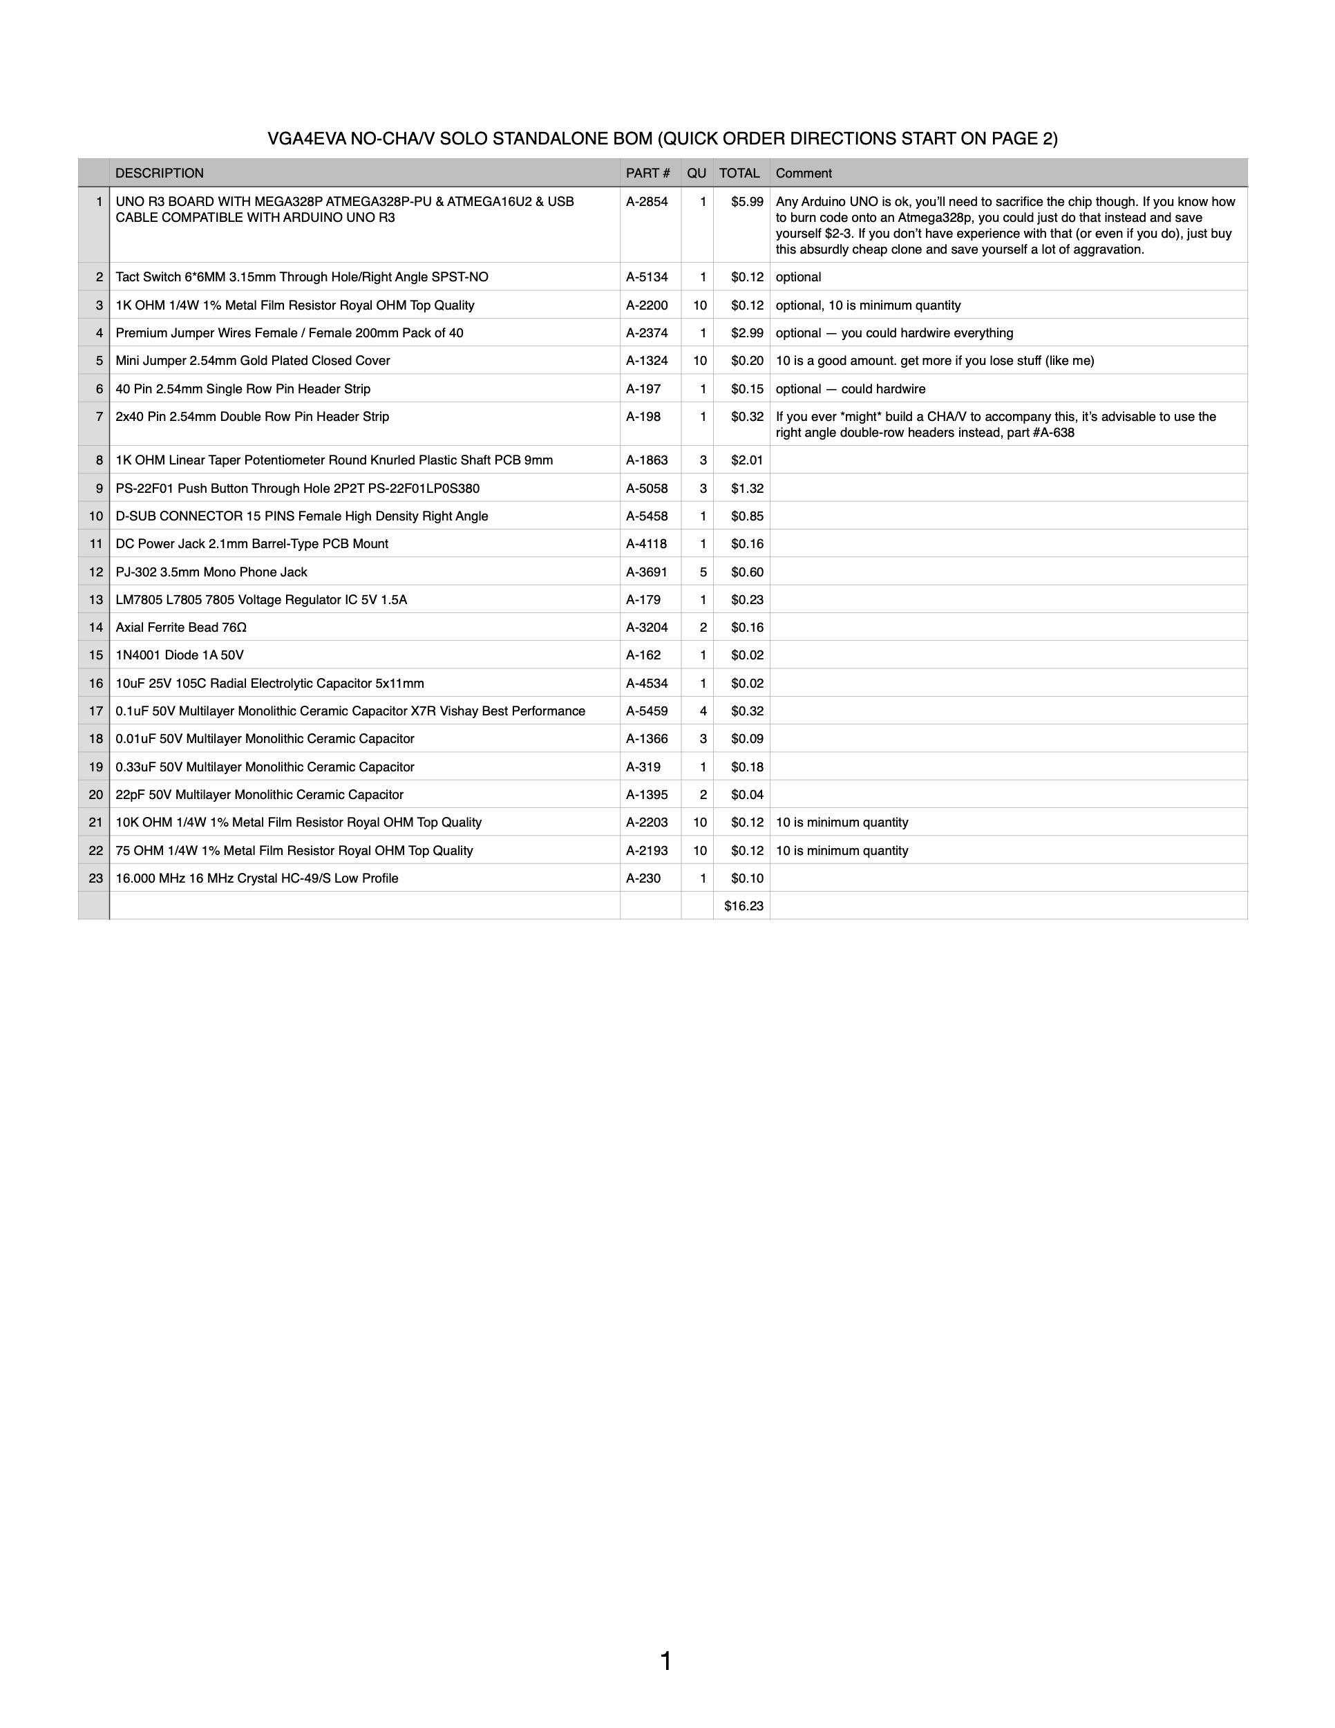
All of the part numbers are from Tayda.com, which is the most inexpensive site I've found that's still easy to navigate, has reliable shipping, and has parts that aren't absolute garbage. Also, they stocked some of this stuff because I asked them to, which blew my frickin mind.
Consider upgrading to express shipping (DHL or UPS) if you're impatient. It's not much more expensive and it's much faster.

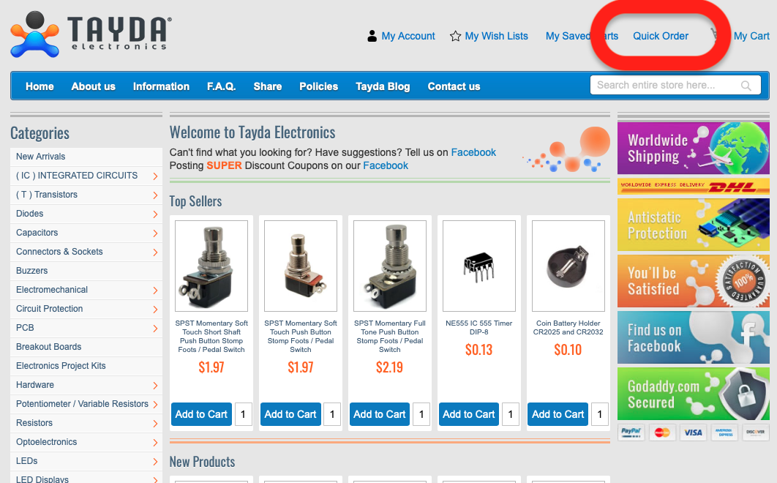
Tayda recently added a "quick order" option that allows you to copy/paste a list of part numbers for painless ordering. They have a tool to import spreadsheets too, but I've never gotten it to work.

Quick order is awesome because I don't have to make kits, and you don't have to pay me to make kits. You can still get the exact parts that you need without spending an hour clicking on stuff and then worrying that you ordered the wrong thing or that you forgot something. You can also easily customize your cart if you want some extra parts.

How to Quick Order in 6 steps:

1) Open a new tab, navigate to Tayda.com., and click on "Quick Order".

(continued below)

2) Copy the following list (this is everything you need for a standalone VGA4EVA that won't be used with a CHA/V):

A-230, 1
A-2193, 10
A-2203, 10
A-1395, 2
A-319, 1
A-1366, 3
A-5459, 4
A-4534, 1
A-162, 1
A-3204, 2
A-179, 1
A-3691, 5
A-4118, 1
A-5458, 1
A-5058, 3
A-1863, 3
A-198, 1
A-197, 1
A-1324, 10
A-2374, 1
A-2200, 10
A-5134, 1
A-2854, 1

(continued below)

3) Paste the list you just copied into the "Add Multiple Products" window circled in the pic below:
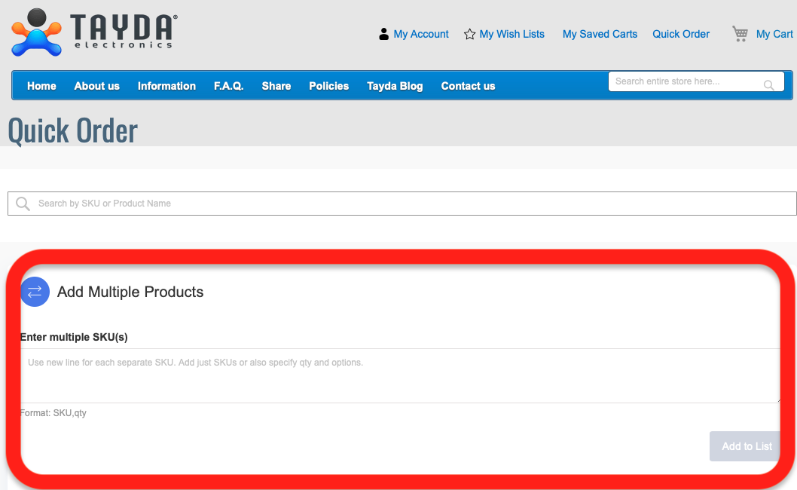

4) Click "Add to list".

5) Scroll to the bottom of the Quick Order page. As you scroll, you should see the parts you just added. You can easily delete things that you already have or change the quantities.

6) Click "Checkout" and complete your order. An easy way to double check that your order is correct is to compare the subtotal price with the total price on the BOM above. Parts costs occasionally fluctuate, but it should at least be within a few dollars.

Note: Things are occasionally out of stock. If something is out of stock, make note of what it is and when it will be back in stock. It's up to you if you'd like to substitute something, but I'd recommend that you wait until the thing is back in stock and then order the whole list at once.

